Mr Victor
Hazel

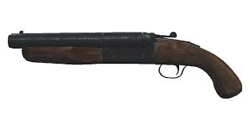
Would like to firmly invite you YES – YOU! to theee greatest shooting party of all time!
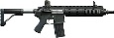
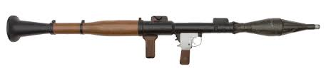
Date: 1st of October
Time: 1:30 P.M. SHARP!
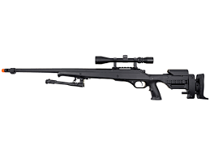
Location: Hazell’s Wood
Guaranteed over 200 pheasants to shoot!!
