Harry Ferguson

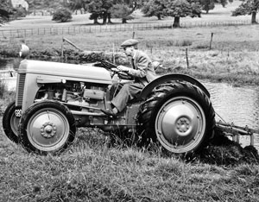
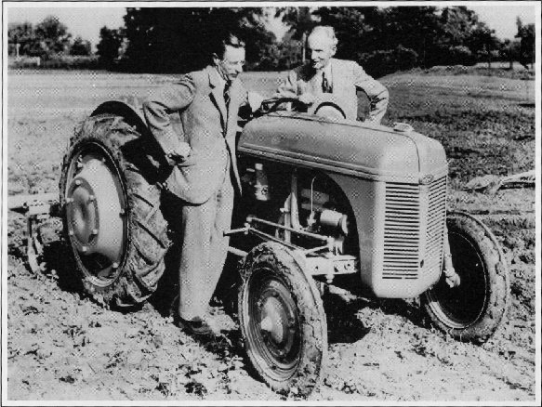
Harry Ferguson was the first person to make Massey Ferguson and the four-wheel drive system. As a consequence of Dagenham`s failure to make the tractors, Harry Ferguson made a deal with Sir John Black of the Standard Motor Company to refit their armaments factory at Banner Lane, Coventry. Production of the latest Ferguson tractor, the TE20, started I the autumn of 1946, over 20,800 TEs being built by the end of 1947. To fill the gap in Ferguson's sales in the US, thousands of TEs were shipped over from England. Harrys real name is Henry George Ferguson. The young Harry Ferguson became fascinated with the newly emerging technology of powered human flight and particularly with the exploits of the Wright brothers, the American aviation In the 1900s pioneers who made the first plane flight in 1903 in North Carolina, USA. After falling out with his brother over the safety and future of aviation Ferguson decided to go it alone, and in 1911 founded a company selling Maxwell, Star and Vauxhall cars and Overtime Tractors. Ferguson saw at first hand the weakness of having tractor and plough as separate articulated units, and in 1917 he devised a plough that could be rigidly attached to a Model T Ford car—the Eros, which became a limited success, competing with the Model F Fordson
In 1917 Ferguson met Charles E. Sorensen while Sorensen was in England scouting production sites for the Fordson tractor. They discussed methods of hitching the implement to the tractor to make them a unit (as opposed to towing the implement like a trailer). In 1920 and 1921 Ferguson demonstrated early versions of his three-point linkage on Fordson’s at Cork and at Dearborn. Ferguson and Henry Ford discussed putting the Ferguson system of hitch and implements onto Fordson tractors at the factory, but no deal was struck. The hitch was mechanical at the time. Ferguson and his team of long-time colleagues, including Willie Sands and Archie Greer, soon developed a hydraulic version, which was patented in 1926. After one or two false starts, Ferguson eventually founded the Ferguson-Sherman Inc., with Eber and George Sherman.

Daniel Cullen

