L.I: To write part of the Myth Finn Mc Cool as a playscript.

[Finn runs into the house in a hurry]
Benandonnar: WHERE’S FINN??
Oonagh: He is away in Kerry, but he will be back soon.
Benandonnar: I might as well wait.
Oonagh: You can come in if you like I can show you all of Finn’s things
[Benandonnar nods his head]
Benandonnar: All right but they’re probably only half the size of mine.
Oonagh: Come in, come in and you can see the baby if you want.
Benandonnar: I’m not very good with babies but I’ll have a look.
Oonagh: I’m making some of Finn’s favourite bread do you want to try some?
[Benandonnar has a look at the baby and sees it’s not a normal baby]
Benandonnar: Your baby is lovely but I think I’ll try the bread now.
Oonagh: Ok come over it is delicious and it’s still warm.
[Benandonnar tries the bread]
Benanddonnar: Oh my this is very warm, OUCH! This is very hard
Oonagh: Do you not like it? The baby loves it.
[Benandonnar jumps up]
Benandonnar: I think I will go now!
Oonagh: But I haven’t shown you the rocks Finn and his friends play with!
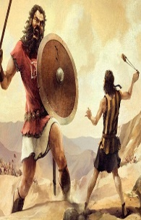
Benandonnar: I’m going, I don’t want to see them!
[Benandonnar goes across the sea back to Scotland]

By Cliodhna and Mary Rose

